**Student Information on SimBio for week 4, 2021**

1. **CHECK YOUR TECH!**  
   Visit <https://simutext.zendesk.com/hc/en-us/categories/200170134-Check-Your-Tech-> to confirm that the SimUText application will work on your computer, and/or to explore your options if there is a problem.
2. **SimUText Voucher Code (optional)**  
   If you purchased a SimUText Voucher from your bookstore, be sure to have it with you when subscribing, as you will need to enter your voucher code.
3. **Registration Link**  
   When you are ready to subscribe and download installers, follow this link to initiate the process: <https://www.simutext.com/student/register.html#/key/UUkV-Kjf3-4drR-dUmX-tztF>
4. **SimUText Application Installers**  
   After you have completed the subscription process, if you need to download the SimUText application installers again, you will be able to access them by logging into the [SimUText Student Portal](https://www.simutext.com/student/) (<https://www.simutext.com/student/>).

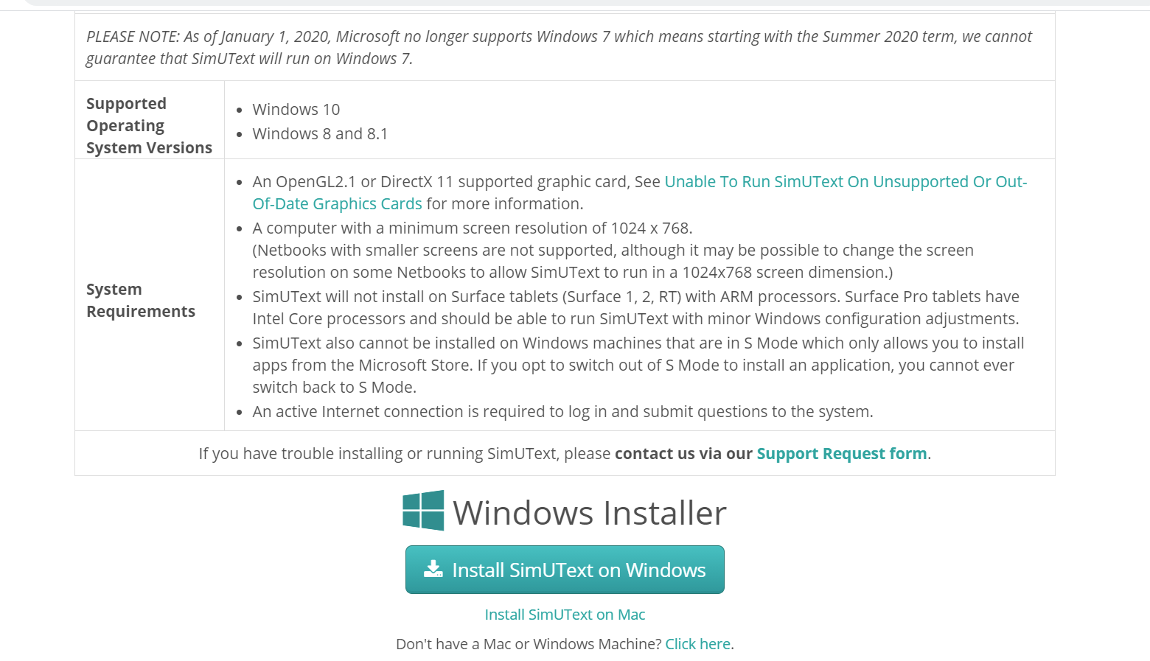

**Save this email!** Should you encounter problems, you may need your course-specific Access Key. It is: **UUkV-Kjf3-4drR-dUmX-tztF**

Problems or questions? Visit [SimUText Support](http://simbio.com/support/simutext)(http://simbio.com/support/simutext)

PLEASE try to download this program before we start lab on Wednesday.